8th Grade Language Arts
Mrs. Ziegler
Room 802
Website: http://fortheloveofreading8.weebly.com
Please sign up for Remind 101 ASAP! To do so please text the code @mrszsl (including the @ symbol) to this number: 81010
Goals:
This year we will read, analyze, and compare several different genres. Some you may have never heard of before.

We will also be writing….A LOT. You will write a persuasive, narrative, and informational paper. You will explore the concepts of writing and how to use proper grammar and spelling as well as how to use sensory details to make your writing pop!

This year I will also be asking you to think outside the box! This classroom is an open and free environment full of ideas and respect. I will also ask you to be more creative than you have ever been and to feel comfortable enough to speak your mind! But remember respect is key! Everyone has an opinion and every is entitled to agree to disagree!

Supplies:
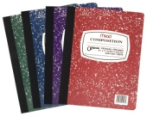 A composition notebook for bell ringers
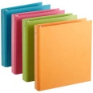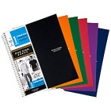A binder or a notebook with pockets for notes and writing prompts
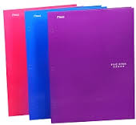 A two-pocket folder for classroom handouts
Class rules:
- Respect all classmates, teachers, property, and yourself: We are a family and only succeed if we have mutual respect for one another.
- NO CHEWING GUM! Spit it out before you sit down. If you stick it, you will pick it!
- Be prepared: Have all materials from your locker before you enter the room. Sharpen your pencil, get your folder, paper, etc before you sit down.
- Turn assignments in on time! I can’t grade it if it’s not turned in!

Expectations:
Bell ringers: This year you will become more responsible for your work and actions. Each day you will have bell ringers to complete in your composition notebooks. You will have 5 minutes to complete them and then we will have a 5 minute class discussion. Your bell ringer will be graded every Friday. (Must be left in class this day) If you are absent, you are to be responsible for going to my website to complete the bell ringer. An absence does not excuse you from a bell ringer.
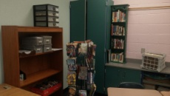
Areas of the room
This is the classroom library. You can check out books at your leisure. Also feel free to write a review about the book and place it on the review wall. If you read a book you really enjoyed, write the title and author on a bookworm and place it on the wall.
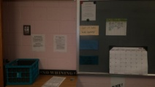
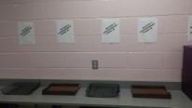
This is the student corner. This is where you will borrow art supplies turn in any work or make-up work. This area is to stay clean and organized. If it becomes messy or if Mrs. Z has to clean up, you will lose your privileges to use the provided art supplies. As a class, you are responsible for keeping this area clean!
This is the exit slip corner. Each class, you will grab a tongue depressor. At the end of class you will place your depressor in one of the following pockets. Here you will also find missed work plans.

Bathroom: You will need your agenda signed to use the bathroom. This will only be allowed during the last ten minutes of class and your bathroom use will be limited to 4 times per quarter…so use them wisely!
40 BOOK CHALLENGE!
In 8th grade you will be continuing to participate in the 40 book challenge, however; this year will look a little different than previous years. You will receive a sheet to log our books but you will not be required to complete assignments for a grade when you read. HOWEVER, you will be required to read 20 minutes a night and get your reading log signed each day to be checked weekly for a grade. You can read anything from a novel to an article, to something online (and no….your Twitter feed doesn’t count!)

Grading/Late Work Policy:
- If you are absent, we will follow the WCPSS policy for making up work.
- If you turn an assignments in late, you will lose 10pts per day it’s late up to 1 week if complete. If you turn in an incomplete late assignment, it will not be graded.
POINTS: 20%: Class work/participation
30%: Minor Assessments
50% Major Assessments
Grading Scale: 90-100 A; 80-89 B; 70-79 C; 60-69 D; below 60 F

